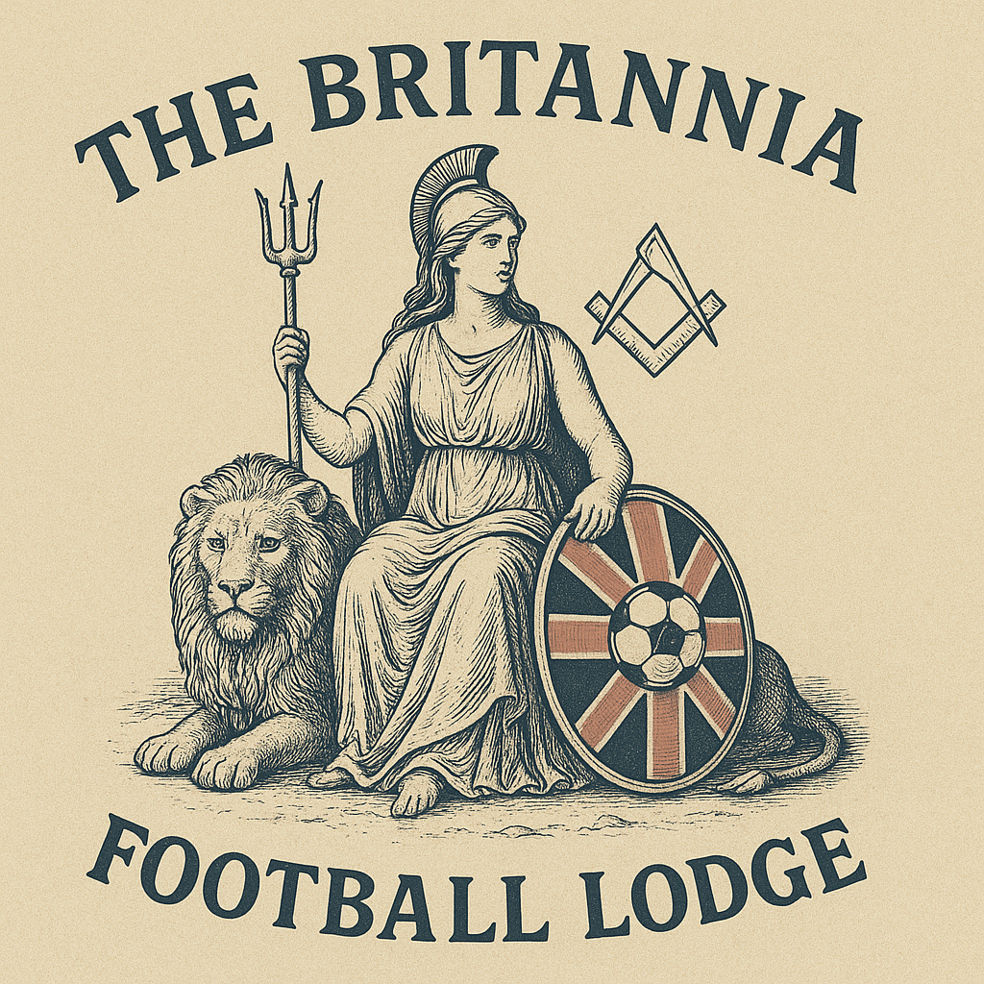
BRITANNIA
FOOTBALL LODGE

FOUNDERS’ PACK
A proposed football-themed Lodge based at Kettering Masonic Centre
Province of Northamptonshire & Huntingdonshire
FOOTBALL • FREEMASONRY • FRIENDSHIP • SERVICE
Revised Formation Edition | 7 October 2026

Inside the founders’ pack
1. Purpose of this Pack
2. The Britannia Vision
3. Becoming a Founder
4. What We Ask of a Britannia Founder
5. The Founders’ Pledge
6. Proposed Lodge Dynamic
7. Aims and Ambitions
8. Membership & Recruitment Strategy
9. Governance and Founding Structure
10. Proposed Founding Officers
11. Formation to Consecration Roadmap
12. Later-stage Founder Information Form
13. Founders’ Register
14. First 24 Months - Success Measures
15. Constitutional & Provincial Reference Notes
Working formation document. The intended base is Kettering Masonic Centre, with proposed Friday Lodge meetings and Saturday match visits. Exact dates, frequency, final arrangements, appointments, costs, partnerships, branding and approvals remain to be confirmed. This revised edition aligns the pack with the website’s full pledge and eligibility declarations; it is not the formal petition.

1. Purpose of this Pack

This pack is intended for Brethren considering becoming Founders of Britannia Football Lodge. It sets out the proposed identity, purpose, founder expectations, governance principles, recruitment approach and the practical steps required to move from concept to a successful and sustainable Lodge. The intended base is Kettering Masonic Centre.
The proposition
Britannia Football Lodge will use a shared passion for football as a gateway to friendship, engagement and high-quality Freemasonry. It is intended to embrace the whole game - professional, semi-professional, non-league, grassroots, coaching, refereeing, administration, volunteering and supporters - rather than being attached to any single club or league.

2. The Britannia Vision

The name Britannia reflects the intention that the Lodge should be broad and inclusive in its football identity, welcoming connections with the game across England, Scotland, Wales and Ireland while being firmly rooted in the Province of Northamptonshire & Huntingdonshire. Kettering Masonic Centre is the intended home of the Lodge.
- Create a vibrant special-interest Lodge with a distinctive football identity.
- Provide a genuine route into Freemasonry for men connected with or passionate about football.
- Build relationships with professional, semi-professional, non-league and grassroots football.
- Deliver enjoyable meetings without compromising the quality, dignity or standards of Craft Freemasonry.
- Use football to strengthen fellowship between members, visitors, families and the wider community.
- Create a Lodge that is sustainable beyond its founding generation through active recruitment, mentoring and succession planning.

3. Becoming a Founder

The constitutional starting point is Rule 94 of the UGLE Book of Constitutions. A petition for a warrant for a new Lodge must be signed by not fewer than seven Master Masons regularly registered under UGLE. The petition must identify the Lodges to which each signatory belongs or has belonged and be accompanied by the appropriate Rule 175 certificates showing that the signatory is not indebted to those Lodges.
Important
Seven is the constitutional minimum for the petition; it is not the recommended operating strength for Britannia. The objective should be a substantially larger and genuinely committed founding group capable of filling offices, delivering ceremonies, recruiting, mentoring and supporting the Lodge socially during its early years.

Founder eligibility checklist
- Be a Master Mason regularly registered under UGLE and eligible to sign the petition.
- Be in good standing and acknowledge that full current/former lodge names and numbers and Rule 175 certificates showing no indebtedness must be provided later when requested, before inclusion in the petition. These details and certificates are not requested at initial sign-up.
- Be willing to be named as a Founder and support the petition and consecration process.
- Accept the aims, culture and football identity of Britannia Football Lodge.
- Be prepared to contribute time, attendance and practical support during the formative years.
- Where taking office, accept the additional commitment associated with establishing a new Lodge.
The Brother nominated as the first Worshipful Master must meet the qualification prescribed by the Book of Constitutions for the first Master of a new Lodge. Final eligibility and petition documentation should be confirmed with the Provincial Grand Secretary before submission. There is no general requirement that every founder be a Past Master or have held Office. The first Master has a specific qualification under the prescribed petition, which must be confirmed with Province. Initial sign-up records awareness and agreement to provide lodge details and certificates later, not that they have already been supplied. Online or printed interest forms do not themselves make a Brother a petitioning founder.

4. What We Ask of a Britannia Founder

Founder status should represent more than having a name on the warrant. The early years will determine whether Britannia becomes a sustainable Lodge. Each Founder is therefore asked to make a meaningful contribution according to his circumstances and abilities. Founding is not simply another notch on one’s belt: attendance, preparation and practical service matter more than a name on a list.
Attendance: Make Britannia a priority and attend regular meetings, rehearsals and key founding events wherever reasonably possible.
Office: If accepting an office, carry out the duties of that office properly and support a stable succession plan.
Ritual: Prepare properly, support rehearsals and help the Lodge deliver ceremonies to a standard of which the membership can be proud.
Recruitment: Actively identify suitable Joining Members and potential Candidates, particularly through football and sporting networks.
Mentoring: Help newer Brethren understand both Freemasonry and the culture of the Lodge; support them through ceremonies and progression.
Football engagement: Help create genuine relationships with clubs, leagues, officials, volunteers, supporters and football organisations.
Social life: Support match visits, family events, charity activity and the Lodge’s wider social programme.
Culture: Protect a welcoming, respectful and non-partisan atmosphere. Club rivalry belongs in friendly banter, never in division.

5. The Founders’ Pledge

A commitment to the Lodge
This pledge is an internal statement of intent and culture. It does not replace or alter obligations under the Book of Constitutions, Lodge by-laws or Provincial requirements.

Founders’ Commitment
As a Founder of Britannia Football Lodge, I recognise that the success of this Lodge will depend upon the commitment, enthusiasm, and active participation of its founding members.
By accepting the honour of becoming a Founder, and particularly by accepting an Office within the Lodge, I make the following pledge:

I Pledge:
1. To place the interests of Britannia Football Lodge above my personal ambitions and preferences.
2. To attend Lodge meetings regularly and make every reasonable effort to fulfil the duties of any Office I undertake.
3. To prepare diligently for any ceremonial, administrative, or organisational responsibilities entrusted to me.
4. To support the Worshipful Master and his Officers in maintaining the highest standards of Freemasonry.
5. To promote harmony, friendship, and mutual respect amongst all members of the Lodge.
6. To actively assist in recruiting, welcoming, mentoring, and retaining new members.
7. To support Lodge social events and charitable activities wherever possible.
8. To act as a positive ambassador for Britannia Football Lodge, both within Freemasonry and beyond.
9. To communicate openly and honestly should circumstances arise that affect my ability to fulfil my commitments, ensuring suitable arrangements can be made.
10. To remember that the early years of the Lodge are critical to its long-term success and that my commitment as a Founder carries a special responsibility to future generations of members.

Office Holder Commitment
Any Founder accepting Office additionally undertakes:
- To attend a minimum of 75% of Lodge meetings.
- To attend Lodge of Instruction meetings where practical.
- To ensure a suitable deputy or replacement is arranged if unable to attend.
- To complete all tasks associated with their Office in a timely and professional manner.
- To serve the Lodge for the full term of Office wherever possible.
- To provide a minimum of twelve months' notice where they intend to step away from a key Office, allowing succession planning to take place.

Closing Declaration
“As a Founder of Britannia Football Lodge, I accept that I am not merely joining a Lodge; I am helping to build its future. I therefore give my word that I will support the Lodge with my time, effort, and commitment, so that future generations of Freemasons may enjoy a thriving Lodge founded upon friendship, integrity, and a shared love of football and Freemasonry.”
Signed: __________________________________________
Name: ___________________________________________
Date: ____________________________________________
This is the complete pledge accepted in the online founder application. It is an internal commitment statement and does not replace the Book of Constitutions, Lodge by-laws or Provincial requirements. Pledge version: 2026-10-07-v1

6. Proposed Lodge Dynamic

Britannia should feel unmistakably like a football Lodge while remaining unmistakably a Masonic Lodge. The football theme should enhance the experience rather than become a gimmick.
Area | Proposed approach
Identity | Football across all levels: professional, semi-professional, non-league and grassroots.
Ritual | High-quality Craft ritual, with members supported according to ability and experience.
Meetings | Proposed Friday Lodge meetings at Kettering Masonic Centre, the intended base. Exact dates, frequency and final arrangements to be agreed with Province and the founding group.
Festive Board | Good-quality, sociable dining with football personality and visiting encouraged.
Saturday match visits | Where practical, follow Friday Lodge meetings with Saturday non-league match visits within the Province, strengthening friendships while supporting smaller clubs. Visits depend on fixtures and practical arrangements.
Charity & service | Support Masonic charity alongside football-related community causes, especially grassroots and youth development.
Brand | Britannia identity using football and national symbolism in a way appropriate for a UGLE Lodge; final badge, banner and regalia subject to approval where required.

7. Aims and Ambitions

- Promote Freemasonry among men with a genuine interest or involvement in football.
- Build a network extending from professional clubs through semi-professional and non-league football to grassroots clubs and volunteers.
- Work constructively with appropriate football bodies and local football networks to raise awareness of the Lodge and of Freemasonry.
- Create a route into Freemasonry for men aged 18 and over, including younger adults for whom a special-interest Lodge may be more accessible and relevant. This is a future candidate pathway, not founder eligibility; initiation remains subject to Rule 157 and all other requirements, including the restriction at age 18 while in full-time secondary education or training.
- Deliver excellent ceremonies while maintaining a relaxed, friendly and enjoyable Lodge culture.
- Encourage members to visit other Lodges and encourage football-minded Masons from other Provinces to visit Britannia.
- Use match visits and football events to create fellowship beyond formal meetings.
- Raise funds and volunteer time for Masonic and local football/community causes.
- Build a sustainable succession pipeline so that the Lodge does not depend indefinitely on its Founders.

8. Membership & Recruitment Strategy

Northamptonshire & Huntingdonshire has actively promoted the Members’ Pathway and special-interest Lodges. Britannia should be designed from the outset around planning, attraction, engagement, mentoring and retention rather than relying on occasional recruitment.

Primary recruitment channels
- Existing Masons with a strong interest in football.
- Contacts within professional and semi-professional football.
- Non-league and grassroots clubs across Northamptonshire & Huntingdonshire.
- Coaches, referees, administrators, volunteers, sponsors and former players.
- Provincial and UGLE membership enquiries where football is identified as an interest.
- Introductions through Founders and Joining Members.
- Public-facing football and community events conducted in accordance with Provincial/UGLE guidance.

Membership principles
- Football is the common interest; suitability for Freemasonry remains the essential criterion.
- The Lodge should not become associated with, or dominated by, one football club.
- Recruitment must be matched by mentoring and retention.
- Candidates should understand the commitment of membership before joining.
- New members should be encouraged to progress at a pace appropriate to them, not simply to fill offices.

9. Governance and Founding Structure

The Lodge should establish disciplined governance before consecration. A Founders’ Committee can coordinate the formation phase, with formal Lodge governance taking over once the Lodge is constituted.

Suggested formation workstreams
Workstream | Lead | Purpose
Provincial liaison | TBC | Petition, approvals, timetable and consecration requirements.
Secretary / administration | TBC | Founder records, meetings, correspondence and document control.
Membership | TBC | Founder recruitment, joining members, candidates and Members’ Pathway.
Ritual & ceremonies | TBC | Officers, rehearsals, ritual support and ceremony planning.
Finance | TBC | Founding budget, fees, subscriptions and financial controls.
Football partnerships | TBC | Club, league, FA and football-community relationships.
Communications & brand | TBC | Identity, website/social channels, launch materials and approved messaging.
Social & charity | TBC | Match days, family/social programme and charitable activity.

10. Proposed Founding Officers

Names can be added as the Founders’ group develops. The final first Master and Wardens must satisfy the applicable UGLE requirements and be approved through the petition process.
Office | Proposed Brother | Confirmed
Worshipful Master |  | ☐
Senior Warden |  | ☐
Junior Warden |  | ☐
Chaplain |  | ☐
Treasurer |  | ☐
Secretary |  | ☐
Director of Ceremonies |  | ☐
Almoner |  | ☐
Charity Steward |  | ☐
Membership Officer |  | ☐
Mentor |  | ☐
Senior Deacon |  | ☐
Junior Deacon |  | ☐
Assistant Director of Ceremonies |  | ☐
Organist |  | ☐
Assistant Secretary |  | ☐
Inner Guard |  | ☐
Stewards |  | ☐
Tyler |  | ☐

11. Formation to Consecration Roadmap

1. Establish the core Founders’ group
Confirm the concept, likely founding strength, leadership team and commitment to the Founders’ Pledge.
2. Engage Province
Agree the process, expectations, meeting arrangements at Kettering Masonic Centre, timetable and documentation with the Provincial Grand Secretary / Provincial leadership.
3. Finalise the Lodge proposition
Confirm name, purpose, meeting pattern, dining model, financial assumptions, membership profile and football engagement strategy.
4. Confirm Founders and first officers
Verify eligibility, collect Lodge history details and obtain required clearance certificates.
5. Sponsoring Lodge recommendation
Arrange the formal recommendation required under Rule 94, including the required notice on the summons and approval in open Lodge.
6. Prepare and submit the petition
Complete the prescribed petition and supporting documentation through Province for onward submission.
7. Prepare the Lodge infrastructure
Draft by-laws, banking/finance arrangements, subscriptions, membership records, summons format, communications and meeting administration.
8. Prepare for consecration
Confirm ceremonial team, founders, regalia/furniture, banner/branding, dining, guests, rehearsals and communications.
9. Launch the first-year programme
Have ceremonies, candidate support, recruitment activity, football events and officer succession planned before consecration.
10. Review after year one
Assess attendance, finances, recruitment, retention, ritual, mentoring and whether the founding model is working as intended.

12. Later-stage Founder Information Form

Later-stage confidential working template: complete it only when the founding team requests these details for petition preparation. Initial sign-up requires only acknowledgement that current/former lodge details and Rule 175 certificates will be needed later; you are not asked to provide them now. Do not post completed forms or certificates publicly. Formal petition information must use the prescribed UGLE / Provincial process. Additional rank, Office history and membership identification details are for secure follow-up when needed.
Full name
Preferred name
UGLE / membership number (if required, secure follow-up only)
Every current Lodge: full name and number (continue separately if needed)
Every former Lodge: full name and number, or “none” (continue separately)
Current Masonic rank
Offices held
Preferred Britannia office / role
Football club(s) supported
Football involvement / connections
Skills or experience offered to the Lodge
Email
Telephone

Initial Sign-up Acknowledgements
☐ I confirm that I am a Master Mason regularly registered under UGLE.
☐ I understand that I will need to provide the full names and numbers of all my current and former lodges, together with a Rule 175 certificate from each confirming that I am not indebted to it, at a later stage. I agree to provide these when requested by the founding team before I am included in the petition.
No lodge lists, certificate-readiness answer or certificates are required at this initial stage. The founding team will request and verify them securely later.
☐ I wish to be considered as a Founder of Britannia Football Lodge.
☐ I support the aims and proposed culture set out in this Founders’ Pack.
☐ I understand that formal Founder status is subject to the applicable UGLE and Provincial process and approvals.
☐ I accept the complete Founders’ Pledge in section 5, not an abbreviated substitute.
☐ If accepting Office, I additionally accept the Office Holder Commitment, including 75% attendance, diligent duties, succession planning and the minimum twelve months’ notice for stepping away from a key Office.

Founder Declaration & Signature
By signing below, I confirm that I wish to be considered as a Founder, support the aims and culture described in this pack, and accept the full Founders’ Pledge. I understand this is not the formal petition, an appointment to Office or automatic admission; eligibility, certificates and approvals remain subject to verification.
Name: _________________________________________________
Signature: _________________________________________________
Date: _________________________________________________

13. Founders’ Register
Blank administrative template. Keep any completed register private and share it only with authorised organisers. “Confirmed” must not be treated as a substitute for eligibility, certificate checks or formal approvals.
No. | Founder | Lodge / No. | Proposed role | Confirmed
1 |  |  |  | ☐
2 |  |  |  | ☐
3 |  |  |  | ☐
4 |  |  |  | ☐
5 |  |  |  | ☐
6 |  |  |  | ☐
7 |  |  |  | ☐
8 |  |  |  | ☐
9 |  |  |  | ☐
10 |  |  |  | ☐
11 |  |  |  | ☐
12 |  |  |  | ☐
13 |  |  |  | ☐
14 |  |  |  | ☐
15 |  |  |  | ☐
16 |  |  |  | ☐
17 |  |  |  | ☐
18 |  |  |  | ☐
19 |  |  |  | ☐
20 |  |  |  | ☐

14. First 24 Months - Success Measures

The Lodge should agree measurable indicators before consecration. The following provide a practical starting framework.
- Healthy attendance at each regular meeting, with Founders setting the standard.
- A functioning officer succession plan rather than dependence on a small number of Past Masters.
- A clear pipeline of suitable candidates and joining members.
- Every new member allocated meaningful mentoring support.
- At least one football/community engagement activity between regular Lodge meetings.
- A Saturday non-league match-visit tradition following Friday Lodge meetings, where fixtures and logistics allow.
- Financial performance within the approved budget and subscriptions set at a sustainable level.
- Positive visiting and inter-Lodge relationships across the Province and with other sports-themed Lodges.
- An annual review of membership, retention, ritual, finances, social activity and founder engagement.

15. Constitutional & Provincial Reference Notes

This pack is a working formation document, not a substitute for the Book of Constitutions or instructions issued by the Provincial Grand Lodge of Northamptonshire & Huntingdonshire.

Key reference points used in preparing this pack
UGLE Book of Constitutions - Rule 94: Application for a warrant for a new Lodge: minimum seven Master Masons regularly registered under UGLE; Lodge-history disclosure; Rule 175 certificates; sponsoring Lodge recommendation; and Provincial transmission where applicable. The constitutional minimum of seven is not a recommended operating strength.
UGLE Book of Constitutions - new Lodge petition / constitution provisions: The prescribed petition and the qualifications/appointments for the first officers should be checked against the current edition when the formal paperwork is prepared.
Members’ Pathway: planning, attraction, engagement, mentoring, succession and retention should underpin the Lodge. UGLE’s 27 September 2024 article records the Province’s use of these principles and the contribution of special-interest Lodges; it does not establish approval of Britannia.
Leather on Willow proposal (September 2023): Used as the structural inspiration for the special-interest Lodge proposition, including mentoring, ritual support, social identity, membership strategy and sustainability. This is background inspiration identified by the supplied source document, not evidence of Provincial approval.
Before circulation as a formal petition pack
Confirm the current petition form, required certificates, fees, first Master qualification, sponsoring Lodge process, proposed by-laws, meeting venue/dates and any approvals required for branding, regalia or special practices with the Provincial Grand Secretary.
UGLE — Book of Constitutions (current edition and downloads)
UGLE — June 2026 Craft Rules: Rules 94, 96, 157 and 175
UGLE — Northamptonshire & Huntingdonshire Members’ Pathway article
Provincial Grand Lodge of Northamptonshire & Huntingdonshire

BRITANNIA FOOTBALL LODGE
FOOTBALL • FREEMASONRY • FRIENDSHIP • SERVICE
Founders build the Lodge.
The members who follow will define its future.

